Macro-damage Behaviour of Al-6Mg Alloy Impacted by
标题三号Time New Roman加粗，居中
A4纸，页面设置：
上下各25 mm, 左右各28mm
论文最好不超过6页
Projectiles with Velocities of 1-7 km/s
摘要五号加粗，单倍行距，段前、段后各0.5行

J. S. Zhou, L. Zhen, G. A. Li, D. Z. Yang
Author 用五号字，Address用小五号字，中间对齐，单倍行距

Harbin Institute of Technology, Harbin 150001, People's Republic of China

Abstract
Damage behaviors of a LF6 alloy under the impact of GCrl5 steel projectiles with velocities of 1~7 km/s have been studied. The results show that, craters formed in semi-infinite targets impacted by projectiles with lower velocities are a columned one with a hemispherical bottom. With increasing the impact velocity, the shape of craters changes into hemispherical gradually.
摘要正文首行缩进2字符，小五号字，单倍行距，

二级标题小四号加粗，段前、段后各0.5，单倍行距，所有二级标题相同

Keywords: Damage behaviors; GCrl5 Keywords用斜体，三到五个关键词，中间用分号隔开
- Introduction
正文用Time New Roman，五号字，单倍行距，首行缩进2个字符，全文相同
Aluminum alloys are widely used as structural materials for airplanes and space vehicles, due to their lightweight, high specific strength and high specific modulus. During their application, aluminum alloy parts are likely to be impacted by strong load, for example, the collision of a flying bird with an airplane, the strong impact of meteoroids and space debris with space vehicles, etc. Early studies of damage behaviors of aluminum alloys caused by hypervelocity impacts are derived from the erosion of the space vehicles by hypervelocity meteoroids. With the rapid increase of activities for exploring the space by human being, large number of debris have been produced in the space^{[1-4]}.
参考文献用五号字，上标
- Experimental
The composition (wt.%) of the target material is Al-6Mg (LF6), and that of projectiles is Fe-l.0C-l.65Cr-0.4Mn-0.37Si (GCrl5). Physical and mechanical properties of the two alloys are shown in Table 1. The thickness of targets changes from l0 to 50 mm, and projectile diameters are 1 mm, 1.65 mm, 2 mm and 3 mm, respectively. Spherical GCrl5 steel projectiles were fired by an explosion accelerator with speeds of 1~ 7 km/s.
Table l Physical and mechanical properties of target and projectile materials
表格字体为五号，标题段前0.5行，居中
Materials | E  GPa | HB  MPa | ρ  g/cm³ | C_{v}  J/kg.°C | T_{m}  °C | α  x10⁻⁶°C⁻¹ | Poisson’s ratio  μ
LF6 | 70 | 850 | 2.64 | 921 | 660 | 22.8 | 0.337
GCr15 | 196 | 1900 | 7.85 | 473 | 1535 | 11.0 | 0.3
3. Results and Discussion
三级标题为五号加粗，单倍行距，段前0.5
3.1 Change of crater morphology and size with projectile velocities
The macro-damage on targets caused by hypervelocity impacts is a crater. The damage tapes change with the projectile velocity (ν₀) and the target thickness (δ). However, there is a common feature for craters in different conditions, that is, a projecting outer fringe is always observed in the “mouth” of craters, and the root of the fringe connects with the target, showing that the fringe is extruded from the crater. Figure 1

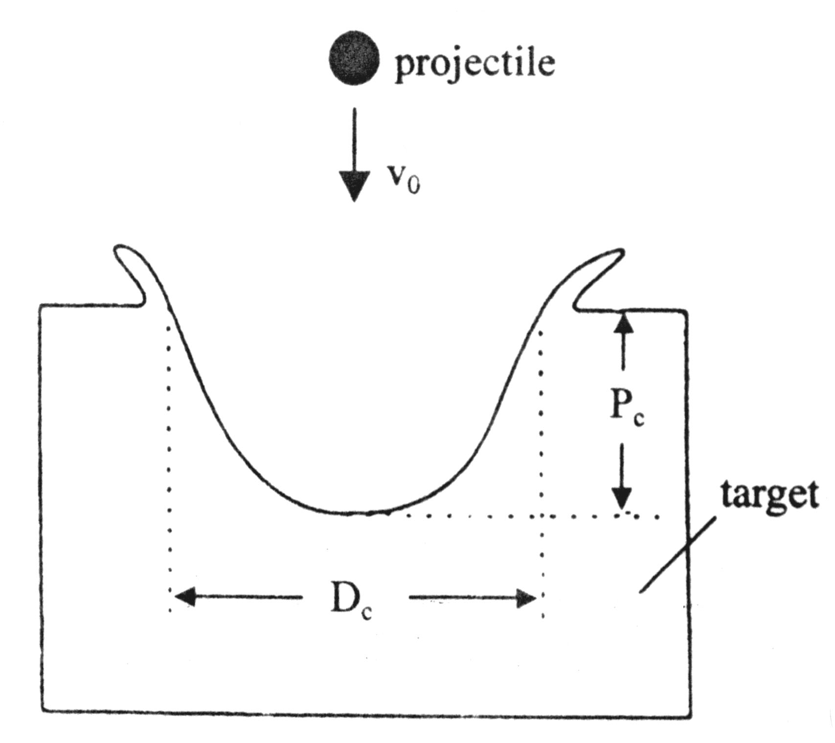
图标注释用五号字
Fig.1 Definition of crater depth and diameter
- Conclusions
The morphology of craters formed in LF6 targets changes with the target thickness and the projectile velocity. With increasing the impact velocity, the crater formed in semi-infinite targets changes from the shape of a column with a hemispherical bottom into hemispherical shape gradually. Craters formed in medium-thick targets usually show conical shape with obvious spall phenomena.
References
[1] E.Potter Andrew. Measuring the Orbital Debris Population. Earth Space Review. 1995, 4:21~29.
参考文献小五号字，单倍行距
[2] T.H. See, M.K. Allbrooks, et al. Meteoroid and Debris Impact Features Documented on the Long Duration Exposure Facility. NASA JSC Report # 24608, l990: 561.
[3] W. Flury. Space Debris Related Activites of ESA. USCOPUOS, S&T SC. February 1995.
[4] Laurnce, M.R., Brownlee, D.E. The flux of meteoroid and orbital debris striking satellites in low earth orbit. Nature, l986, 323: 136
[5] H.A. Zook. Deriving the velocity distribution of meteoroids from the measured meteoroid impact directionality on the various LDEF surface, in LDEF –69 Months in Space. First Post-Retrieval Symposium, NASA CP 3134, 1992: 569~580

